Quarch Technology Ltd

AN-022

Application Note

QPS automation with FIO

For use with:
XLC Power Modules
HD Power Modules
Quarch Power Studio (QPS)

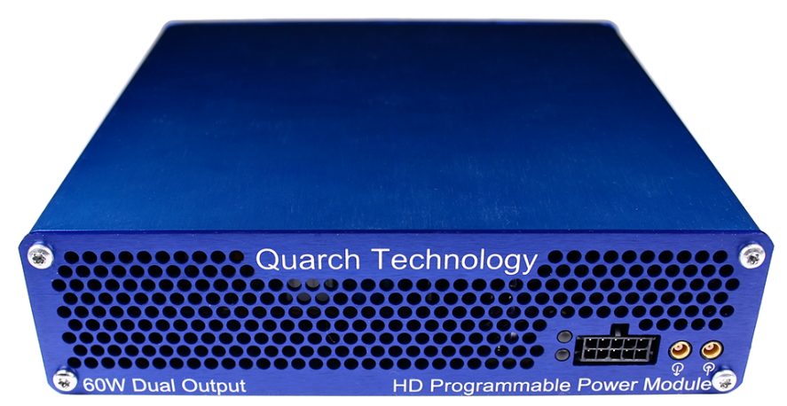

Change History
1.0 |  | Initial Release
1.1 | Feb 2019 | Updated to Python 3.x
1.2 | May 2019 | Updated for quarchpy 2.x
1.3 | November 2022 | Updated descriptions and instructions

Contents
Change History 2
Introduction 4
Modules Supported 5
System Supported 5
Application Note Example Files 5
Installation and setup 5
Python install 5
QuarchPy library install 6
Java install 8
QPS install 8
FIO install 8
Power module setup 9
Running the example 10

Introduction
Simple automation allows us to capture data from a power module into a CSV file, and post process it to gain more information.
In this example we will capture data at a fast rate then re-sample it to several different slower rates to see how min and max values change at higher averaging levels.
This requires a Quarch PPM or PAM and the quarchpy python package

Modules Supported
XLC power modules
- QTL1824 (QTL1824-02A modules do NOT support streaming, but can be upgraded by Quarch)
- QTL1847
HD power modules
- QTL1995
- QTL1999
PAM modules
- QTL2312

System Supported
This example is written and tested on Windows, though could be used on MacOS and Linux as long as FIO is installed.
It currently requires Python 3.x

Application Note Example Files
The AN-022.zip should be extracted to your preferred location.
PowerExample.py | Main python file to execute

Installation and setup

Python install
If you do not already have Python 3.x installed, download and install it from:
https://www.python.org/downloads/
Under Windows it is helpful to make sure the Python installation directory and PythonXX\Scripts are included in the PATH environment variable. See:

https://docs.python.org/3/using/windows.html#excursus-setting-environment-variables

QuarchPy library install
The Quarch Python package can be installed from the Python web repository (assuming you have internet access) or via the download from our website.
Quarchpy will also install a version of Quarch Power Studio

Web Install
From the command line:
>pip install quarchpy
If this fails, your path to “pip” may not be set, you can instead run:
>python –m pip install quarchpy

Local Install
If you want to install from a downloaded folder, ensure the folder is unzipped to a local disk, navigate to the folder containing the setup.py file and run (noting the ‘.’ on the end):
>pip install quarchpy .
If this fails, your path to ‘pip’ may not be set, you can instead run:
>python –m pip install quarchpy .

Upgrade
If you already have QuarchPy installed, you will get a failure message. If you want to upgrade to a new version, you need to add the ‘--upgrade’ command:
>pip install --upgrade quarchpy
The --upgrade command can similarly be used in any of the other examples, to load from a local install folder.

Java install
Check that the Java is installed. This can be Oracle Java8, OpenJDK-8 or Coretto-8
See our Java guide here
https://quarch.com/support/faqs/java/

Power module setup
Connect the power module to the test PC and the output of the power module to the drive under test.

Customer Drive
USB/LAN Connection
Power Module
Customer Test PC

Running the example
Run PowerExamples.py
- You will be prompted to select the Quarch power module you want to connect to.
- The script should now run to completion which will take a few seconds
  - The capture time can be edited by changing the range(5) command after the startStream() call
- The output will be 4 files
  - The raw captured data
  - Post processed data to 100uS averaging
  - Post processed data to 500uS averaging
  - Post processed data to 1mS averaging
- Each file will contain the resampled data and a simple MIN/MAX/AVE statistic set at the bottom

